МИНИСТЕРСТВО НАУКИ И ВЫСШЕГО ОБРАЗОВАНИЯ

РОССИЙСКОЙ ФЕДЕРАЦИИ

ФЕДЕРАЛЬНОЕ ГОСУДАРСТВЕННОЕ БЮДЖЕТНОЕ ОБЩЕОБРАЗОВАТЕЛЬНОЕ УЧРЕЖДЕНИЕ ВЫСШЕГО ОБРАЗОВАНИЯ

«ОРЛОВСКИЙ ГОСУДАРСТВЕННЫЙ УНИВЕРСИТЕТ   
ИМЕНИ И. С. ТУРГЕНЕВА»

                                                                                                                                                                   Кафедра информационных систем и цифровых технологий

**ОТЧЁТ**

по лабораторной работе № 6

на тему: «Разработка собственного тестового драйвера»

по дисциплине «Качество и тестирование программного обеспечения»

Выполнили: Банных М.А., Мельников А.Е.

Институт приборостроения, автоматизации и информационных

технологий

Направление: 09.03.04 «Программная инженерия»

Группа: 21ПГ

Проверил: Олькина Е.В.

Отметка о зачёте:

Дата: «___»______________ 2025г.

Орёл, 2025

**Потоковый граф**

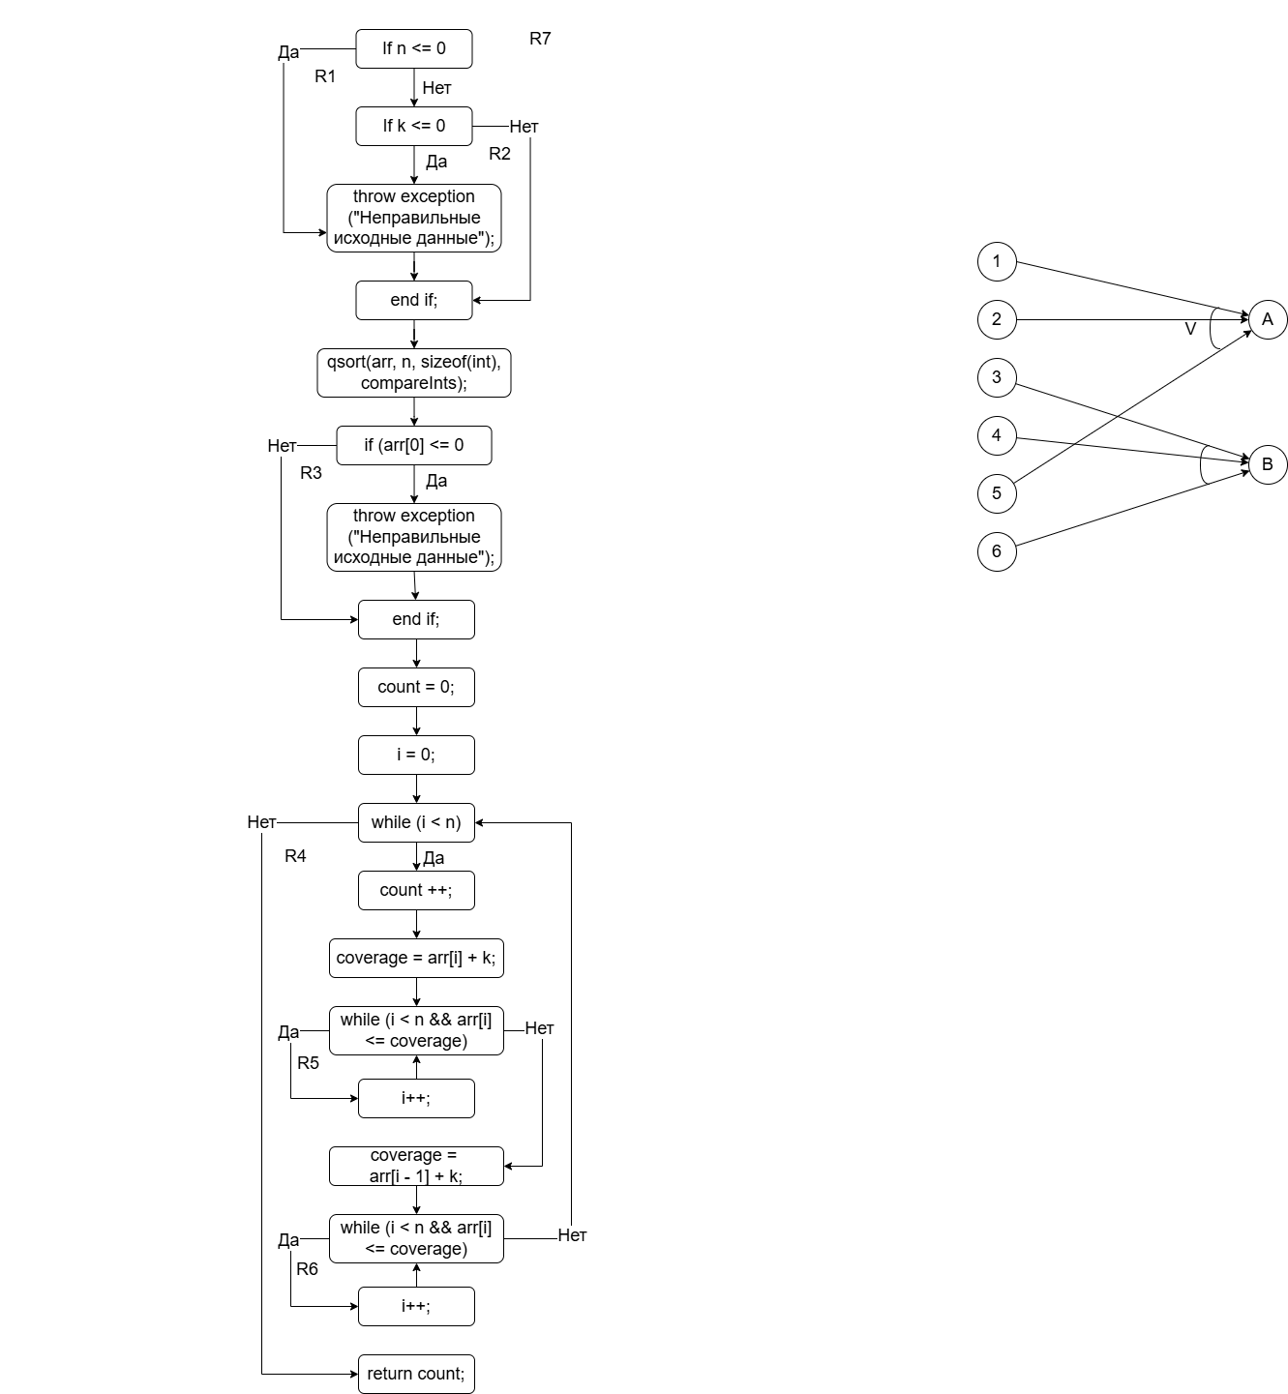

Вычисление цикломатической сложности:

1. 24 дуг – 19 узлов + 2 = 7

2. 6 предикатных узлов + 1 = 7

3. 7 регионов

Пути:

1-3

1-2-3

1-2-4-5-6-7

1-2-4-5-6-8-9-10-11-12-13-14-15-16-17-18-19

1-2-4-5-6-8-9-10-11-12-13-14-15-16-17-19

1-2-4-5-6-8-9-10-11-12-13-14-16-17-19 (невозможен по выражению 10 и условию 2)

1-2-4-5-6-8-9-10-11-19 (невозможен по условию 1)

**Тестируемый модуль**

def countTransmitters(arr, n, k):

if n <= 0 or k <= 0:

raise Exception ("Incorrect source data")

arr.sort()

if arr[0] <= 0:

raise Exception ("Incorrect source data")

count = 0

i = 0

while(i < n):

count += 1

coverage = arr[i] + k

while (i < n and arr[i] <= coverage):

i += 1

coverage = arr[i-1] + k

while (i < n and arr[i] <= coverage):

i += 1

return count

**Тесты**

[

{

"name": "countTransmitters",

"arr": [ [] ],

"k": [ 6 ],

"n": [ 0 ],

"expected_result": "Incorrect source data",

"module": "countingTransmitters"

},

{

"name": "countTransmitters",

"arr": [ [ 3, 1, 4, 6, 2 ] ],

"k": [ 0 ],

"n": [ 5 ],

"expected_result": "Incorrect source data",

"module": "countingTransmitters"

},

{

"name": "countTransmitters",

"arr": [ [ 3, -1, 4, 0, 2 ] ],

"k": [ 6 ],

"n": [ 5 ],

"expected_result": "Incorrect source data",

"module": "countingTransmitters"

},

{

"name": "countTransmitters",

"arr": [ [ 19, 23, 24 ] ],

"k": [ 4 ],

"n": [ 3 ],

"expected_result": 1,

"module": "countingTransmitters"

},

{

"name": "countTransmitters",

"arr": [ [ 1, 9 ] ],

"k": [ 7 ],

"n": [ 2 ],

"expected_result": 2,

"module": "countingTransmitters"

}

]

**Тестовый драйвер**

import importlib.util

import json

from pathlib import Path

class TestDriver:

def __init__(self, module_path, test_file):

self.module_path = module_path

self.test_file = test_file

def load_module(self, module_name):

spec = importlib.util.spec_from_file_location(module_name, self.module_path / f"{module_name}.py")

module = importlib.util.module_from_spec(spec)

spec.loader.exec_module(module)

return module

def run_tests(self):

with open(self.test_file, 'r') as file:

tests = json.load(file)

results = []

for i, test in enumerate(tests, start=1):

try:

module = self.load_module(test['module'])

func = getattr(module, test['name'], None)

arr = test['arr'][0]

k = test['k'][0]

n = test['n'][0]

result = func(arr, n, k)

expected_result = test['expected_result']

status = 'success' if result == expected_result else 'failed'

message = '' if status == 'success' else f"Expected {expected_result}, got {result}"

results.append({

'test_number': i,

'received_result': result,

'expected_result': expected_result,

'status': status,

'message': message

})

except Exception as e:

received_message = str(e)

expected_message = test.get('expected_result', '')

status = 'success' if received_message == expected_message else 'failed'

results.append({

'test_number': i,

'received_result': received_message,

'expected_result': expected_message,

'status': status,

'message': '' if status == 'success' else f"Expected {expected_message}, got {received_message}"

})

return results

def generate_report(self, results):

for result in results:

report = "\n"

report += f"\nTest #{result['test_number']}: {'Success' if result['status'] == 'success' else 'Failed'}"

report += f"\n\tReceived Result: {result['received_result']}"

report += f"\n\tExpected Result: {result['expected_result']}"

report += f"\n\tMessage: {result['message']}" if result['message'] else ""

print(report)

if __name__ == "__main__":

module_path = Path("test_modules")

test_file = "tests.json"

driver = TestDriver(module_path, test_file)

results = driver.run_tests()

driver.generate_report(results)

